DBMS LAB SLOT-L57-58

ASHISH KUMAR DUBEY

17BIT0033

FACULTY – PROF. PARIMALA M

CYCLE SHEET 01

CAT 01

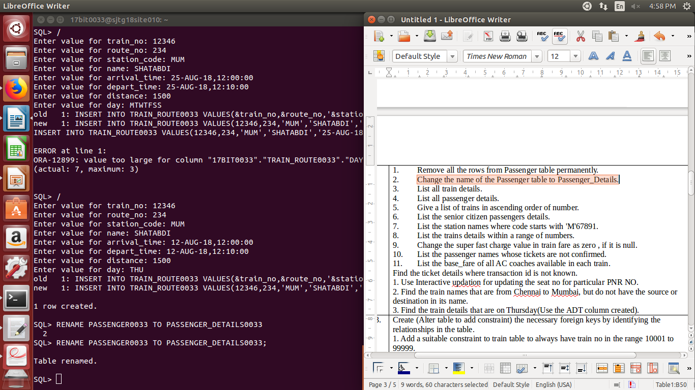2). RENAME PASSENGER0033 TO PASSENGER_DETAILS0033;

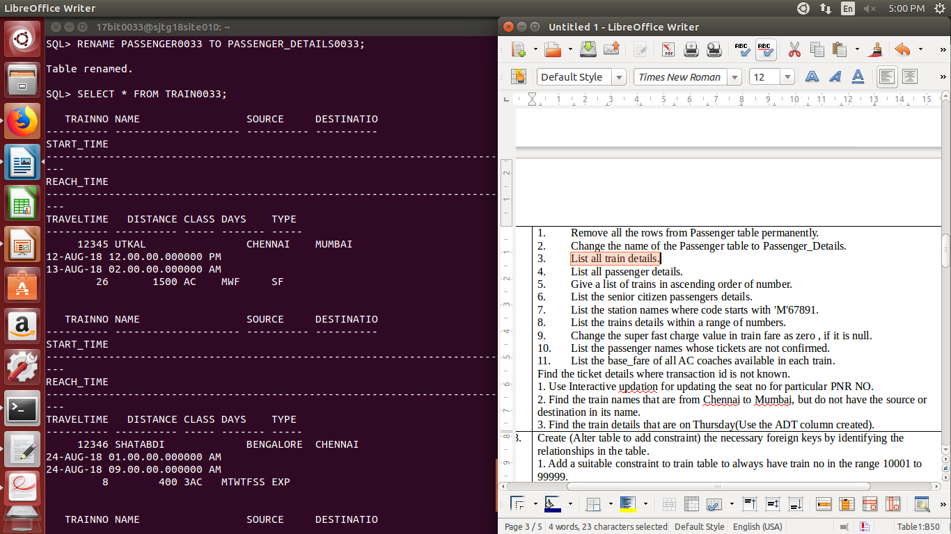3). SELECT * FROM TRAIN0033;

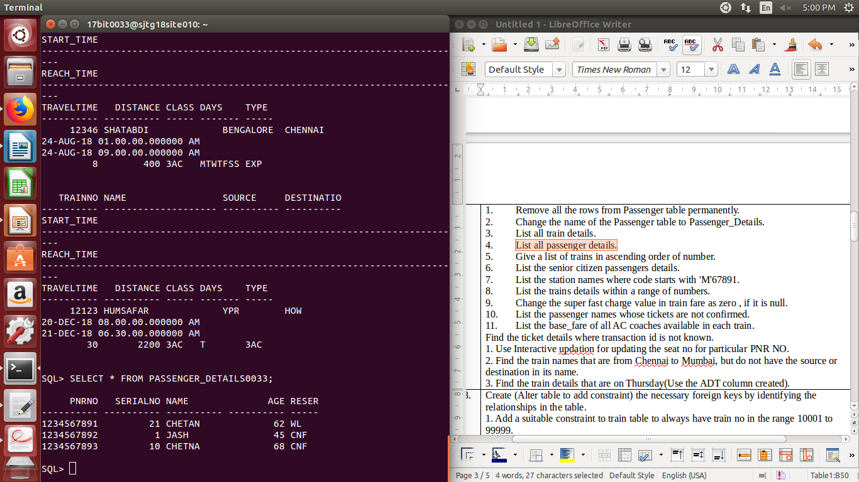4). SELECT * FROM PASSENGER_DETAILS0033;

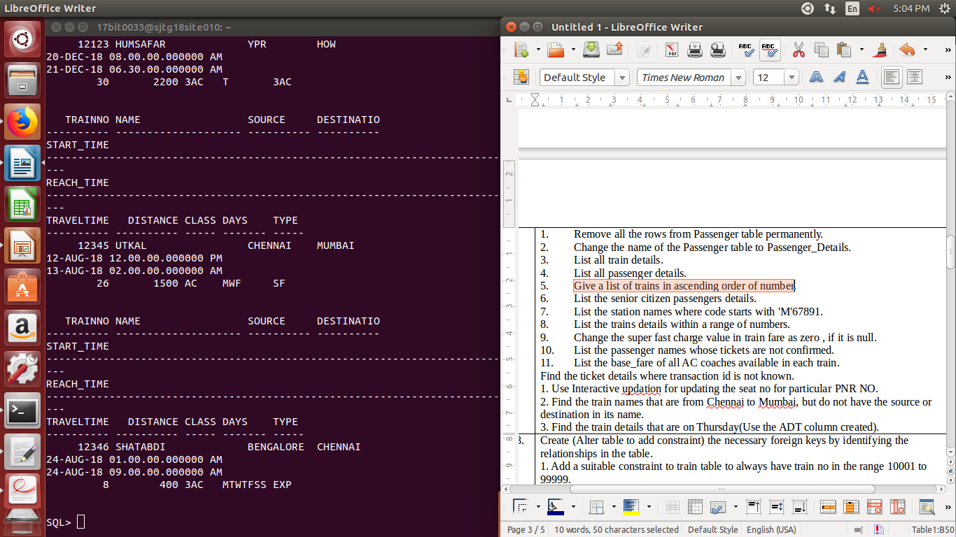5). SELECT * FROM TRAIN0033 ORDER BY trainno;

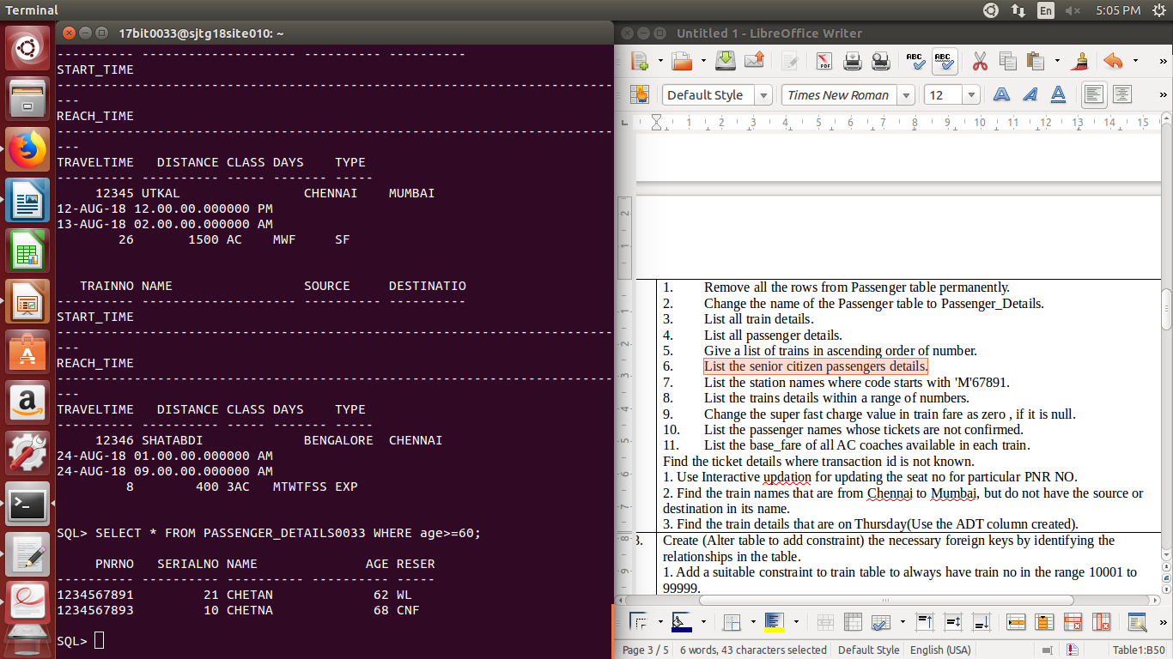6). SELECT * FROM PASSENGER_DETAILS0033 WHERE age>=60;

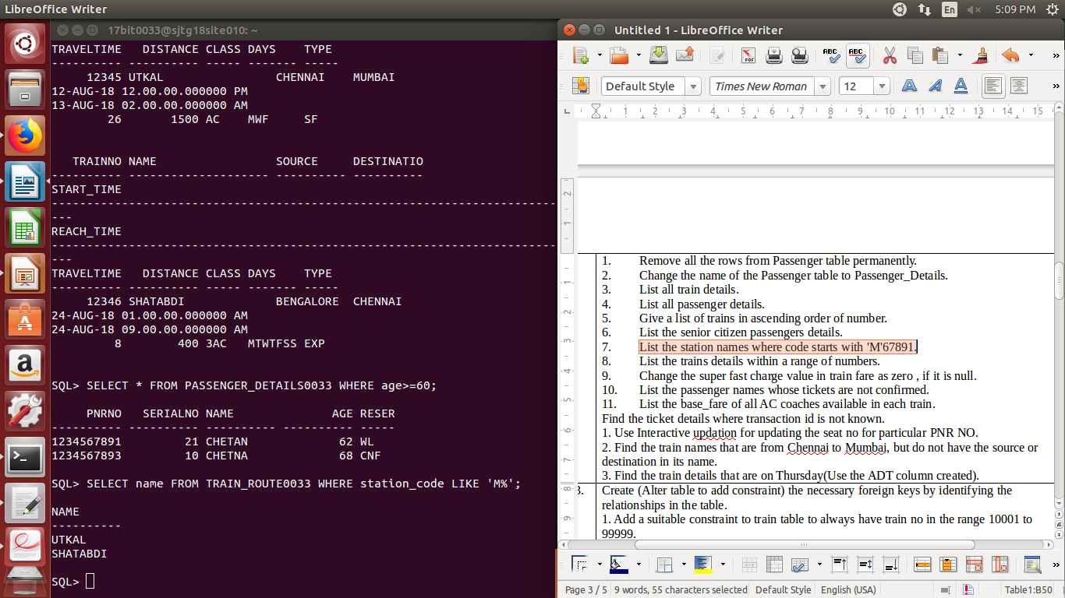7). SELECT name FROM TRAIN_ROUTE0033 WHERE station_code LIKE ‘M%’;

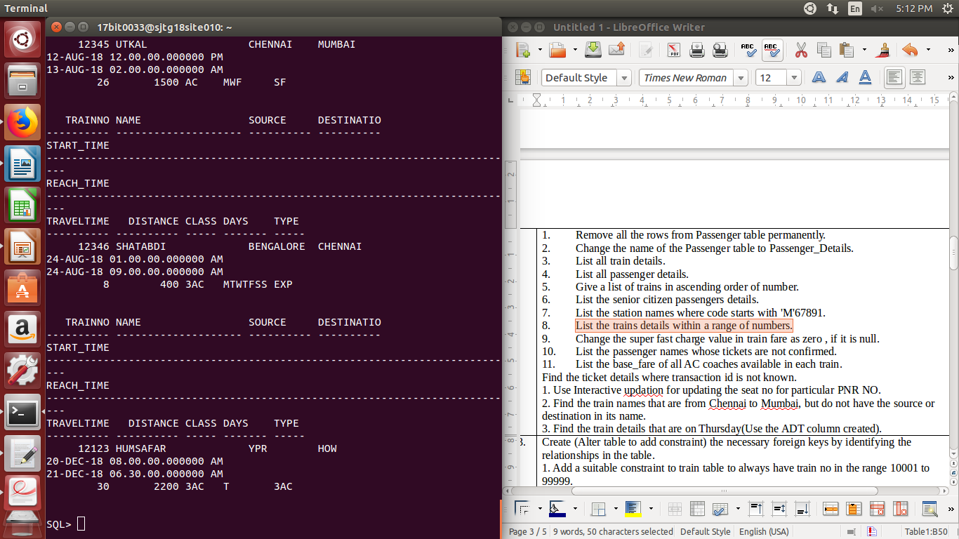8). select * from TRAIN0033 where trainno BETWEEN 10000 AND 99999;

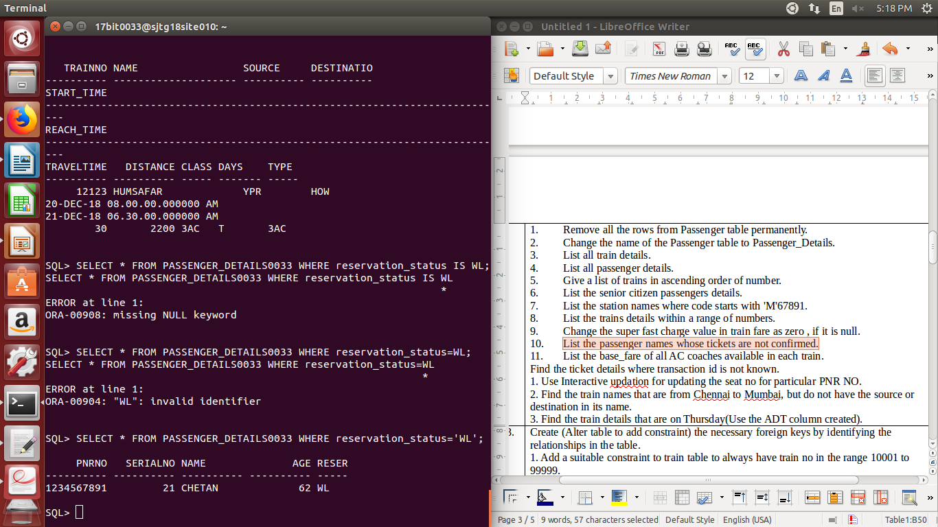10). SELECT * FROM PASSENGER_DETAILS0033 WHERE reservation_status=’WL’;

11). SELECT base_fare FROM TRAIN_TICKET_FARE0033 WHERE class=’3AC’;

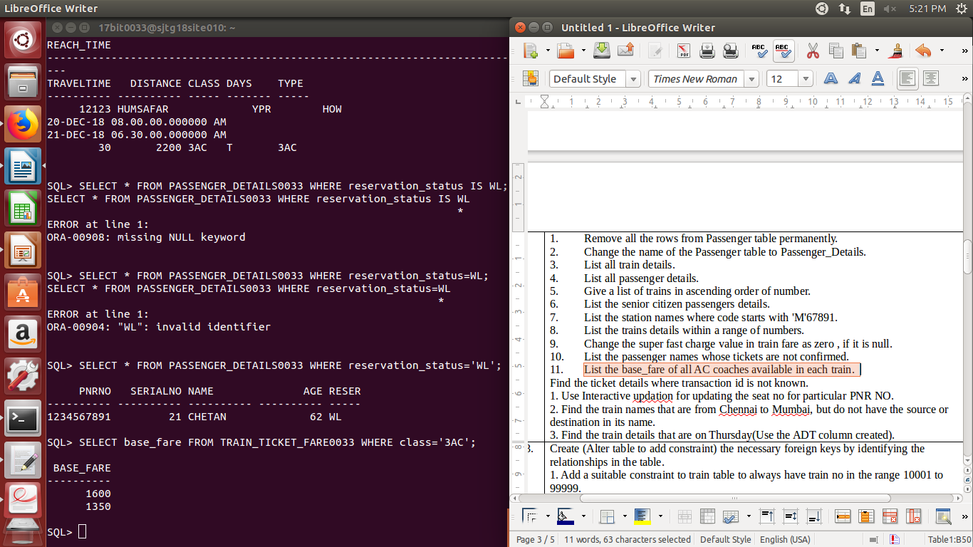

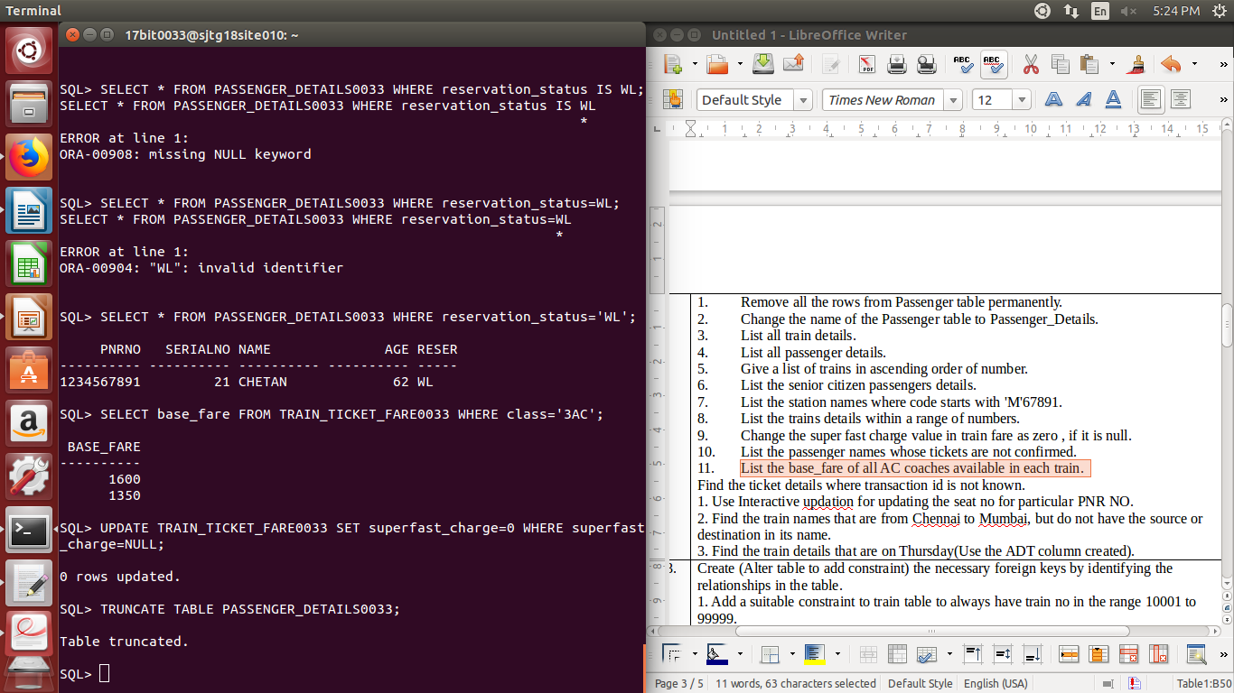

1).

TRUNCARE TABLR PASSENGER_DETAILS0033;

9). UPDATE TRAIN_TICKET_FARE0033 SET superfast_charge=0 where superfast_charge=NULL;



PHASE II

3). SELECT * FROM TRAIN_ROUTE0033 WHERE 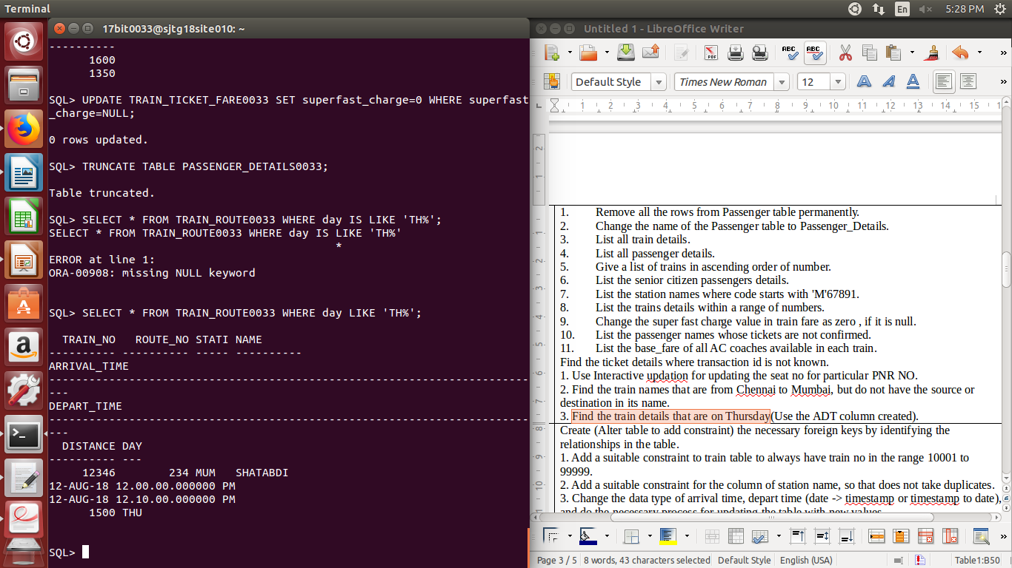day LIKE ‘TH%’;

2). SELECT * FFROM TRAIN0033 WHERE source LIKE ‘CHENNAI’ AND destination LIKE ‘MUMBAI’;

